A Study on the Development Status of the Wuchang Eighteen Martial Arts under the Procedural Grounded Theory

Wenyao Chen ^{1,2}, Mohamad Nizam Bin Mohamed Shapie^{2*},
Mohamad Rahizam Bin Abdul Rahim²

¹Yuhang District Xianlin Middle School, Hangzhou, China
² Faculty of Sports Science and Recreation, Universiti Teknologi MARA, Shah
Alam,Selangor, Malaysia.

Corresponding Author: Mohamad Nizam Bin Mohamed Shapie
Email: nizam7907@uitm.edu.my

Abstract
In 2021, the Chinese government proposed the protection of intangible cultural heritage and formulated plans and outlines for this purpose. This paper, aiming to explore the current development status of Wuchang Eighteen Martial Arts under the Procedural Grounded Theory, is dedicated to better safeguarding and transmitting China's outstanding traditional culture. The study utilizes research methods such as literature review, oral history, and on-site investigations. The research findings are as follows: 1. Within the core domain of habits, the cultural development of Wuchang Eighteen Martial Arts exhibits continuity and inheritance. People have started to unearth more information, forming preliminary processes for excavation, preservation, and development. 2. In the core domain of fields, the development of Wuchang Eighteen Martial Arts is initially influenced by historical backgrounds, resulting in periods of stagnation. However, with current community and public support, these practices are now back on track. 3. In the core domain of cultural capital, the exclusivity of Wuchang Eighteen Martial Arts imparts distinctive advantages. Politically, its cultural soft power is considered a cultural resource and capability with multiple values. By exploring and utilizing these resources and capabilities, contributions can be made to societal sustainable development and cultural prosperity.
Therefore, based on the Procedural Grounded Theory, we undertake research, distilling the core concept of the "Vitality of Wuchang Eighteen Martial Arts" from the central domains of habits, fields, and cultural capital. This concept reveals the inherent principles it embodies when facing the complex and ever-changing social environment.

Keywords: Cultural Field; Wuchang Eighteen Martial Arts; Martial Arts; Intangible Cultural Heritage

1.Introducion
In February 2011, the Chinese government legislated the "Law of the People's Republic of China on the Protection of Intangible Cultural Heritage" [1]. Furthermore, in 2021, the Chinese government explicitly outlined in the "14th Five-Year Plan for National Economic and Social Development and the Long-Range Objectives Through the Year 2035" the need to "thoroughly implement the project for the inheritance and development of outstanding Chinese traditional culture, strengthen the systematic protection of important cultural and natural heritage, as well as intangible cultural heritage, and promote the creative transformation and innovative development of outstanding Chinese traditional culture" [2]. This underscores the nation's profound emphasis on the inheritance and protection of intangible cultural heritage, with martial arts being a significant component. Deciphering the cultural identity of martial arts and rekindling confidence in martial arts culture represent a colossal and intricate systemic endeavor [3].
In reality, China possesses numerous martial arts and weapons awaiting exploration, salvage, and preservation. Presently, experts in history, archaeology, and martial arts have compiled information from ancient and contemporary literature, artifacts, and other sources, identifying up to 440 different types of weapons , as detailed in Table 1-1 [4]. This abundance of weapon varieties in China is noteworthy, with the demonstration of a diverse array of weapons in martial arts, such as the Wuchang Eighteen Martial Arts, being a rare occurrence. However, theoretical research specifically focused on the Wuchang Eighteen Martial Arts is relatively limited, with fewer than 20 articles published, the earliest dating back to 2008. These studies predominantly concentrate on aspects like origin, historical evolution, protection, weapons, and attire. It is noteworthy that three years later, the Wuchang Eighteen Martial Arts were included in the national-level representative project list of intangible cultural heritage. The deepening theoretical research has revitalized the Wuchang Eighteen Martial Arts, providing it with more opportunities to be showcased in local communities, on the international stage, and online, demonstrating this ancient and distinctive martial arts culture. In this study, the Procedural Grounded Theory will serve as the anchor, and methods such as literature review, field research, and oral history will be employed to collect relevant data supporting the theoretical framework of the Wuchang Eighteen Martial Arts.
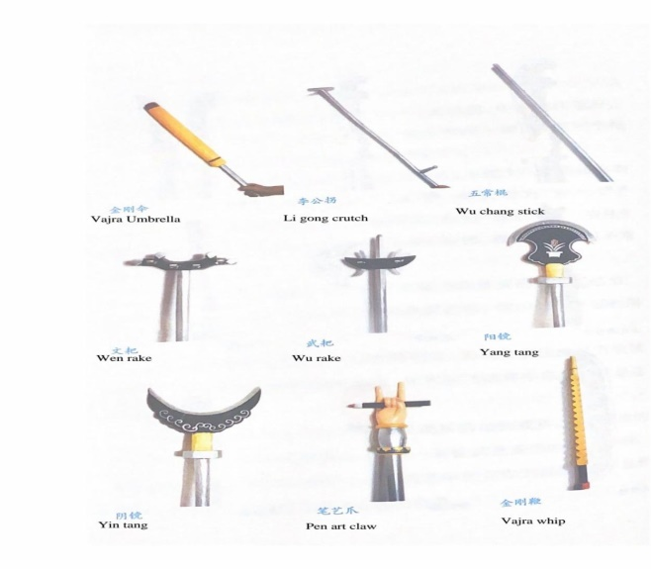

Table 1-1 Various Ancient Chinese Weapons (Partial)
NO. | Name | Number | NO. | Name | Number
1 | Sabre and Sword | 149 | 9 | Whip | 12
2 | Spear | 49 | 10 | Ax and Yue | 11
3 | Stick | 23 | 11 | Ji | 13
4 | Hammer | 14 | 12 | Lance | 6
5 | Crossbow | 52 | 13 | Tang | 6
6 | Bow and arrow | 44 | 14 | Fork | 4
7 | Drill bit | 4 | 15 | Crutch | 5
8 | Claw and Zhua | 14 | 16 | Others | 24

Research process and related concepts
  - Wuchang Eighteen Martial Arts
"The Eighteen Martial Arts," also known as the "Eighteen Weapons," is a specialized term in Chinese martial arts. The use of "eighteen" here does not necessarily denote a specific number but rather conveys a concept of diversity. In Chinese colloquialism, there's a saying, "Mastering the Eighteen Martial Arts means excelling in every aspect," describing a person with exceptional martial skills. In this context, martial arts refer to both weapons and the associated techniques. The term "Wuchang Eighteen Martial Arts" specifically denotes the unique martial arts prevalent in the Wuchang area of Yuhang District, Hangzhou City, China.

(As shown in Fig. 2-1 and 2-2)

Fig. 2-1 Weapons of Wuchang's Eighteen Martial Arts (1)

Fig. 2-2 Weapons of Wuchang's Eighteen Martial Arts (2)

2.2 Procedural Grounded Theory
Grounded Theory is primarily a methodological approach and a systematic method system. Its method system, norms, and rigorous analytical process have been widely applied in various fields of social science. Therefore, it is entirely suitable for the research in this paper. Currently, there are three main schools of Grounded Theory commonly used in academia, and this paper adopts the approach of Procedural Grounded Theory.

2.3 Research process
2.3.1 Problem Emergence
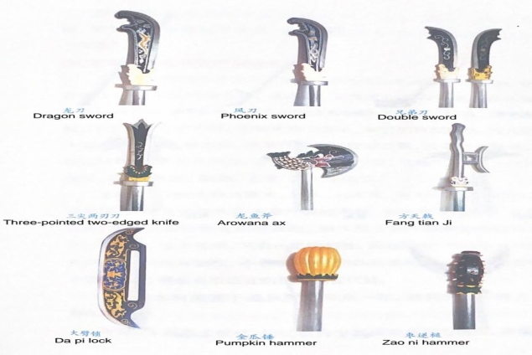
The formulation of research questions in this study fully aligns with the natural emergence requirements of Grounded Theory. Based on the exploration and salvage of Chinese martial arts culture, as well as the review and organization of relevant literature, it was observed that the academic community, both domestically and internationally, lacks in-depth understanding of the Wuchang Eighteen Martial Arts. Therefore, there is a need for a qualitative research approach to conduct a thorough analysis.

2.3.2 Data Collection
This study, based on Grounded Theory, employs methods such as literature review, oral history, and field investigations to grasp the actual situation of the inheritance and development of Wuchang Eighteen Martial Arts. Field visits and surveys are conducted to understand the residents' awareness, recognition, and the current status of the inheritance of Wuchang Eighteen Martial Arts in the Wuchang community. This approach aims to identify existing issues, understand their causes, clarify the thought process, and provide support for the subsequent resolution.

2.3.3 Open Coding
In this study, Mindjet MindManager software (2018) was utilized to process the data, resulting in 104 open codes. As shown in Fig. 2-3.

2.3.4 Axial Coding
Through the integration of the 104 open codes, nine axial codes were deduced, namely, inheritance content, inheritance methods, folk martial atmosphere, historical background, community participation, individuals, exclusivity, cultural soft power, and politics. As depicted in Fig. 2-3.

2.3.5 Selective Coding
In Grounded Theory, this is referred to as the principle of "constant comparison." To determine whether the core category is saturated, three core categories—habit, field, and cultural capital—were extracted from axial coding. As no other core categories emerged, it was determined that the core categories were saturated.

2.3.6 Theory Construction
During the selective coding stage, three core categories—habit, field, and cultural capital—emerged, leading to the identification of the core concept "Vitality of Wuchang Eighteen Martial Arts" (As shown in Fig. 2-3). Based on the relationship between core categories and core concepts, the model of the vitality of Wuchang Eighteen Martial Arts was constructed. If coding saturation is not achieved, a literature review is conducted to supplement any deficiencies, ultimately ensuring that the theoretical model reaches a saturated state.

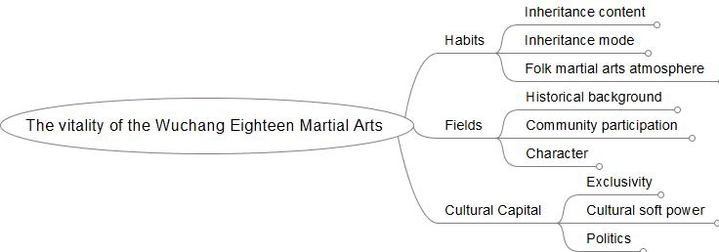
Fig. 2-3 The core concept of "Vitality of Wuchang Eighteen Martial Arts."

Result

3.1 Wuchang Eighteen Martial Arts in the Habit Core Category
Habit is constituted by a series of historical relationships deposited in an individual's body, manifested through various bodily and mental schemas such as perception, judgment, and actions [5]. Similar to concepts like "cultural unconscious," "the power of shaping habits," and "psychological habits," habit serves as a crucial guideline influencing the practices of actors within cultural fields [6]. In other words, habit is a long-term cognitive structure deeply internalized in actors, forming an ingrained tendency system that leads or governs behavior.
Delving into the exploration of Wuchang Eighteen Martial Arts under the core category of habit, a profound investigation into the axial codes of inheritance content, inheritance methods, and the folk martial atmosphere was conducted (As shown in Fig. 3-1 and Table 3-1). It was discovered that this martial arts activity, led by founder Hong Zhong and conducted in the Hong Clan Ancestral Hall, primarily aims to enhance the physical fitness of villagers and improve their self-defense capabilities. Current research indicates a positive correlation between the practice of martial arts, health behaviors, and self-assessment scores of life quality [7]. This martial arts activity, reinforced by cultural unconsciousness, gradually expanded to surrounding villages. After Hong Zhong's passing, villagers dedicated the weapons he taught to the Hong Clan Ancestral Hall, replicating a set that is now kept in rotation by elders in the village.

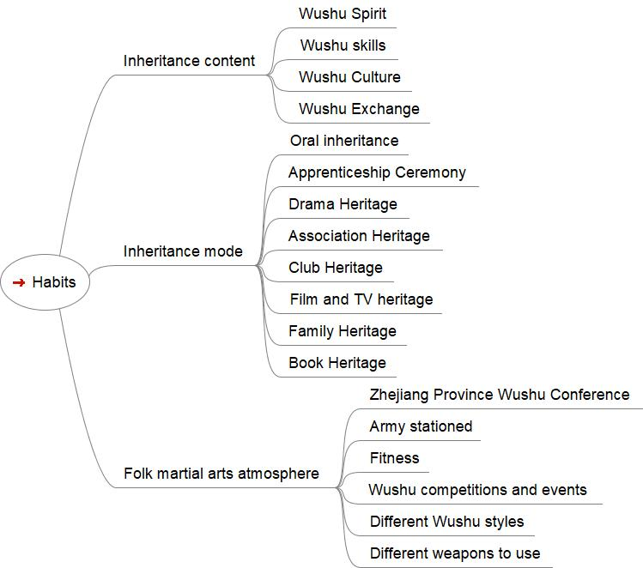
Fig. 3-1 Codes for the Core Category "Habit"

Table 3-1: Data and Open Coding Related to the Core Category "Habit" (Partial)
Open Coding | Data
Patriotism | Since Wuchang Eighteen Martial Arts is war evolutions, there is a spirit of patriotism embedded in them.
Carry forward national traditional culture | Our project is committed to promoting traditional culture and delving into the frontlines of education.
Cultivate a positive attitude | Martial arts have a positive impact on the physical and mental development of adolescents, fostering overall development by cultivating interests and exercising willpower.
Build a strong body | Through training, we have observed improvements in students' strength, speed, and agility.
Sports protection | During training, the coach consistently emphasizes the importance of practicing safely to ensure the safety of both the participants and the weapons.
scientific exercise | Specialized training is arranged for different weapons, with specific instructors assigned to provide expertise in each.
Master-Apprentice Transmission | The traditional practice of martial arts instructors in the past was to teach only their apprentices and not share the knowledge with outsiders. This approach has resulted in the loss of many martial arts techniques.
Campus Heritage | By forming community groups and entering campuses, we promote martial arts activities and cultivate enthusiasts. Effective methods of integrating martial arts into school classrooms have also been explored and put into practice. The use of a tiered training approach and the selection of weapons allow every student to participate and learn the use of various weapons.
cultural confidence | Many parents, upon seeing their children win awards in competitions, actively request continued participation in martial arts learning.
Social skills | Due to the teamwork, many rehearsals require students to communicate and interact with each other, aiming to achieve a perfect performance.
International exchange | Currently, the martial arts team has visited Germany and Brazil for martial arts exchanges.
Zhejiang Martial Arts Conference | At that time, Hangzhou hosted the first Zhejiang Province Martial Arts Conference, and folk martial arts teams actively participated. Until today, the martial arts atmosphere in Hangzhou remains strong.
Military Garrison | In the Song Dynasty, Hangzhou served as the capital, and the vicinity of Wuchang was a location where the military stationed for training.

Under the influence of habits, martial arts activities in this area have created a favorable atmosphere, and Wuchang Eighteen Martial Arts have been successively showcased at Lantern Festivals and temple fairs, becoming popular programs enjoyed by the public. Through research, it was found that around the mid-Qing Dynasty, the Eighteen Martial Arts had already spread throughout Wuchang and neighboring villages. Now, it has expanded to the international stage; in 2004 and 2008, the martial arts team visited Germany and Brazil respectively to exchange experiences. Research indicates that German university students have a relatively low level of awareness and familiarity with Chinese martial arts, mainly due to the slow development of official Chinese martial arts dissemination institutions and methods. Some German male university students who understand Chinese martial arts tend to focus on specific boxing styles and traditional Chinese weapons, while female students prefer Chinese martial arts costumes and culture [8]. Therefore, I believe that such martial arts exchange activities are essential.
Wuchang Eighteen Martial Arts represents the essence of traditional Chinese martial arts, encompassing various skills such as boxing, swordplay, spear techniques, staff techniques, knife skills, and whip techniques. The formation and development of these skills are inseparable from the inheritance and innovation of martial artists throughout the ages, which, in turn, are rooted in a behavioral pattern formed in daily life—habits. The importance of habits in the development of martial arts is illustrated in Table 3-2.

Table 3-2 The Significance of Habits in the Development of Martial Arts
NO. | Open Coding | Connotation
1 | The inheritance of martial arts skills. | Habits enable martial artists to continuously practice and hone their skills in their daily lives, allowing for the inheritance and promotion of these skills. Additionally, habits enable martial artists to flexibly apply their learned techniques in real combat situations, enhancing their combat effectiveness.
2 | The inheritance of martial arts spirit. | Habits are also reflected in martial artists' daily lives and moral qualities, which are essential components of the martial arts spirit. Through habits, martial artists pass on the martial arts spirit to future generations, ensuring its continuity. Qualities such as respecting teachers, valuing integrity, loyalty, bravery, and continuous self-improvement are core elements of the martial arts spirit. These qualities can only be truly appreciated through the practical application of daily life. On one hand, those who continuously strive for self-improvement through martial arts training undergo another test of willpower, reaching their peak once again (Volodymyr, 2022). On the other hand, martial arts are considered a practical embodiment of societal ideals, contributing to the character development of practitioners and benefiting society (Martinkova, Parry, & Vagner, 2019).
3 | The inheritance of martial arts culture. | Habits are also reflected in martial artists' identification with and respect for martial arts culture. Through habits, martial artists pass on martial arts culture, ensuring its continuity. For example, ancient martial artists would conduct initiation ceremonies on specific occasions to express respect for their masters and the transmission of martial arts culture. This tradition is still preserved in many martial arts schools today.
4 | Facilitation of martial arts exchange. | Habits are also evident in the communication and interaction among martial artists. Through habits, martial artists can learn from each other, exchange skills, and promote the dissemination and development of martial arts culture. For example, various martial arts competitions, seminars, and other activities provide a platform for martial artists to showcase their talents and learn from others, thus facilitating deeper exchanges in martial arts.

n conclusion, habits play a crucial role in the development of Wuchang Eighteen Martial Arts. Even after the founder has passed away, as long as the succeeding generations continue to research and learn these skills and culture, the martial arts culture can be passed down and further developed. In the context of globalization, martial arts, as a unique cultural heritage, should be given more attention and preservation, allowing more people to understand and appreciate this profound and extensive art form.

3.2 Wuchang Eighteen Martial Arts in the Field Core Category
The field represents a social space encompassing various social relationships and resources. The author, through research within the field's core category, has synthesized and summarized three main axial codes: historical background, community participation, and individuals. In-depth research has been conducted into these aspects.

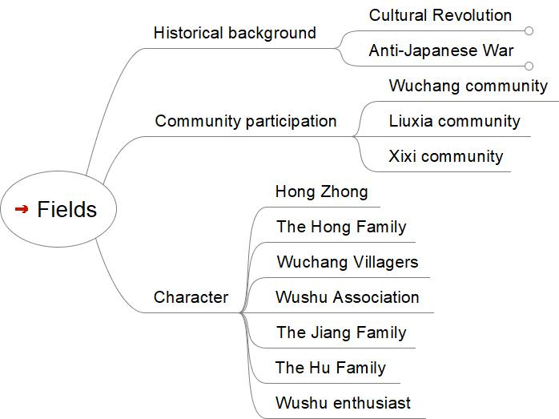
Fig. 3-3 Codes for the Core Category "Field"

"Wuchang Eighteen Martial Arts" boasts a history of over 500 years, distinguishing itself from traditional eighteen martial arts by combining conventional weapons of cavalry and infantry with farmers' tools. This evolution has given rise to Wuchang's unique set of eighteen wooden weapons and exercise methods, creating a martial art that integrates fitness, self-defense, competition, and aesthetics. Due to its close connection with the local living environment, culture, and folk customs, Wuchang Eighteen Martial Arts has been beloved by the local people and has experienced positive development since its inception.
However, factors such as the Anti-Japanese War and the Cultural Revolution led to the gradual decline of Wuchang Eighteen Martial Arts. The villagers lost interest, and the wooden weapons used for practice were gradually lost. Eventually, only one complete set of wooden weapons of Wuchang Eighteen Martial Arts was preserved in its place of origin, the Wuchang Village [9-10].
Presently, the main participants in the protection and inheritance of Wuchang Eighteen Martial Arts come from community engagement. Communities such as Wuchang, Liuxia, and Xixi actively contribute to its preservation. In June 2004, local martial arts experts Hu Qiaoquan and Zhang Jianhua gathered 40-50 martial arts enthusiasts from their village to establish the Wuchang Martial Arts Team, receiving financial support exceeding 500,000 RMB from the government. Without the support of the majority, it would be challenging to seek financial assistance from the government, highlighting the solid grassroots foundation of the Wuchang Martial Arts Team. The team has participated in numerous competitions, achieving excellent results and enhancing its reputation. Currently, the team has grown to over 150 members, spanning a diverse range of ages, from over 90 years old to as young as 6 years old.

Table 3-3 Data and Open Coding on the Core Category 'Field' (Partial)
Open Coding | Data
Cultural Revolution | During the special period of the Cultural Revolution, internal contradictions within the country led to the dissolution of martial arts groups, the suspension of various martial arts activities, and the destruction of weapons. This resulted in a discontinuity in the transmission of martial arts.
Anti-Japanese War | The invasion by external forces led to the dissolution of martial arts groups, the temporary suspension of various martial arts activities, and the destruction of weapons by the state. This resulted in a discontinuity in the transmission of martial arts.
Wuchang Community | The Wuchang community organizes various activities related to the Wuchang Eighteen Martial Arts every year, creating a positive cultural atmosphere within the community.
Hong family | In the inheritance and protection process of the Wuchang Eighteen Martial Arts, the people of the Hong family are one of the important driving forces for development.

The flourishing of a nation, a family, and a martial art is intrinsically tied to the presence of influential individuals. The emergence of key figures significantly influences political systems, policy directions, ideologies, and various aspects. In the development of martial arts in every country, a charismatic leader often emerges to guide its growth. For instance, Anuar Abdul Wahab played a pivotal role in promoting the development of silat pulut in Malaysia [11-13]. When examining the historical development of Wuchang Eighteen Martial Arts, one cannot ignore the significant impact of a prominent figure—Hong [14-17]. This discussion inevitably leads to the mention of the Hong family, belonging to the Qiantang prominent families, with their origins traced back to the Hong family in Poyang, Jiangxi province. Their profound influence on the cultural development of Hangzhou is noteworthy. Research indicates that leaders play a decisive role in determining the progress of the organizations they lead, propelling them to the next level of achievement or even greater heights. An effective leader with a positive impact has the potential to elevate the overall excellence of society [18].
During the Ming Dynasty, the Hong family from Xixi produced five Shangshu officials, reaching the pinnacle of their prestige during the era of Hong Zhong. In 1507, Hong Zhong was appointed as the Shangshu of the Ministry of Justice in Nanjing. In 1509, he served as the Gongbu Shangshu in Beijing. Later, he was appointed as the Shangshu of the Ministry of Justice in Beijing, concurrently serving as Du Cha Yuan Zuo Fu Dou Yu Shi (都察院左都御史). In 1510, he led the armies of five provinces—Sichuan, Shaanxi, Hunan, Hubei, and Henan—to defeat bandits in various regions. The emperor granted him the title of Taishi Taibao. However, Hong Zhong declined the title on seven occasions, preferring to retire to care for his elderly parents.
Throughout his life, Hong Zhong demonstrated both administrative acumen in governance and military prowess in leading armies. Given his various official positions closely related to judiciary and military affairs, he possessed expertise in martial arts, legal matters, and military administration. This expertise provided the foundation for him to create the Wuchang Eighteen Martial Arts. In his later years, Hong Zhong observed that many villagers, after finishing their agricultural work, were idle and prone to conflicts. To change this situation, he combined the weapons used in military campaigns with agricultural and daily tools, ultimately developing a unique set of weapons. Based on military training, he devised 108 sets of martial arts routines, teaching villagers to practice them for the purposes of physical fitness, self-defense, and maintaining public order [19].
His descendant, Hong Zhanzu, followed his teachings diligently, achieving high scholarly and literary accomplishments and mastering military strategy. The emperor bestowed upon him the title of Shangshu of the Ministry of War. Later, Hong Zhanzu resigned from office and spent over forty years in seclusion, contributing significantly to the cultural development of Xixi by advocating and supporting cultural initiatives.
Therefore, the Hong family's political and economic influence in Wu Chang, and even throughout Hangzhou, has been significant. Their subtle impact has shaped the local political ecology and ideology. The Hong family has thrived for over 800 years, producing talented individuals in each generation. As the family became wealthier, their ancestors dedicated efforts to educate their descendants, instilling values and principles for ethical conduct, thus establishing their family ethos.
In modern society, the influence of the Hong family remains strong. They wield extensive impact across various fields, including politics, economics, education, and culture. Members of the Hong family continue to uphold the family's traditions, making positive contributions to both the nation and society.

3.3 Wuchang Eighteen Martial Arts in the cultural capital Core Category
From the perspective of cultural capital, Wuchang Eighteen Martial Arts reveals three main axes of encoding: exclusivity, cultural soft power, and politics. Research suggests that the Wuchang Martial Arts are not only intricate techniques but also carriers of cultural values. The martial spirit embodied in them serves as cultural capital for the nation, encompassing, but not limited to, the pursuit of noble qualities and honor, the understanding and desire for control of the body, and the exploration of the limits of physical activity. These aspects can be regarded as a form of social resources and capabilities (Y. Li, Chen, & Chen, 2020).
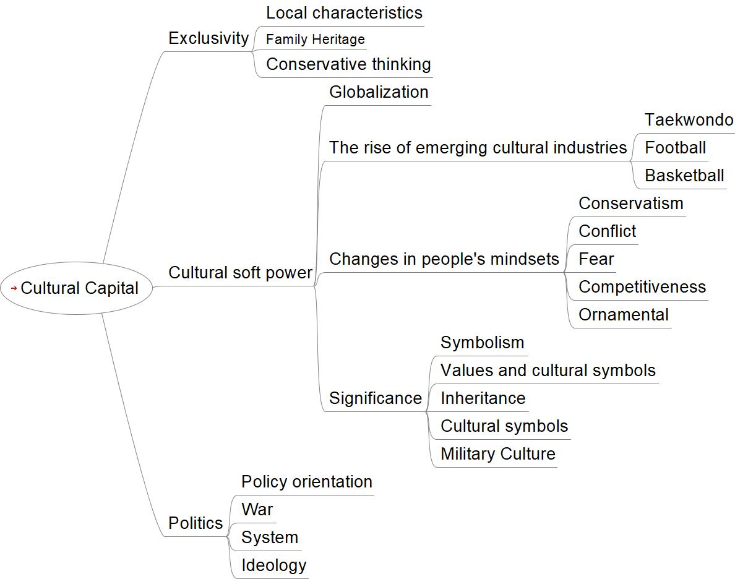
Fig. 3-4 Encoding of the core category "Cultural Capital."

Table 3-4: Data and Open Codingon the Core Category "Cultural Capital." (Partial)
Open Coding | Data
conservative in thought | Respected local master craftsmen advocate a conservative approach towards the development of Wuchang Eighteen Martial Arts, emphasizing the importance of preserving tradition.
Martial Arts Tourism | Currently, the Wuchang Eighteen Martial Arts are often showcased in conjunction with activities at the West Lake Wetland, providing a platform for visitors to experience traditional Chinese culture.
policy guidance | The government is increasingly inclined towards the development of emerging cultural industries, and there is room for improvement in its support for traditional culture.
Values and Cultural Symbols | During that era, it was a cultural trend with participation from every household, reflecting the Hong family's influence on local education. On one hand, it fostered self-defense capabilities, and on the other hand, it enhanced cohesion among the villagers.

Presently, the Chinese government places significant emphasis on the inheritance and protection of intangible cultural heritage. The government work report emphasizes the need to "adhere to self-reliance and firm cultural confidence" and to "persist in creative transformation, innovative development, inherit excellent traditional Chinese culture, meet the growing spiritual and cultural needs of the people, consolidate the common ideological foundation for the unity and struggle of the Chinese people, and continuously enhance the country's cultural soft power and Chinese cultural influence." In this opportune moment, the diverse societal benefits of Wuchang Eighteen Martial Arts come to the forefront. This is evident in reshaping public perceptions of martial arts culture, reflecting societal issues stemming from martial arts development, prompting humanistic care and reflection, and promoting social fairness and progressive development, among other aspects. It serves to meet societal needs and play a role in improving the social environment.
Firstly, Wuchang Eighteen Martial Arts, recognized as a national-level intangible cultural heritage in China, possesses unique cultural value and historical significance. In 2011, through collaborative efforts, a Wuchang Eighteen Martial Arts exhibition hall covering an area of over 300 square meters and with a total investment of over 200,000 RMB was completed at Wuchang Central Primary School, designated as a pilot project for intangible cultural heritage protection in Zhejiang Province. Worldwide, nearly 100 million martial arts practitioners study hundreds of different martial arts systems, each with its own history, experiences, and opportunities.
Research demonstrates that through integration with the cultural industry, martial arts makes undeniable contributions to the development of global tourism. For example, the Russian martial arts event - Atmanov's Kuraichi Traditional Competition. Although martial arts tourism is a niche form of cultural tourism, people's interest in such events is growing, with significant political and economic functions. Its impact extends beyond the economic realm and may influence a country geopolitically [20]Therefore, supported by national policies, integration with the cultural industry has received a solid political foundation. This exclusivity not only protects the uniqueness of Wuchang Eighteen Martial Arts but also affirms and respects its cultural value. Against this backdrop, the inheritance and protection of Wuchang Eighteen Martial Arts receive strong support from both the national and local governments. The government not only provides subsidies to support the protection and inheritance of this significant cultural heritage but also implements a series of policy measures to ensure the sustained development of Wuchang Eighteen Martial Arts. The implementation of these policies provides robust economic support for the inheritance and protection work of Wuchang Eighteen Martial Arts. This not only ensures the smooth progress of this work but also creates a favorable environment for the inheritance and development of Wuchang Eighteen Martial Arts. At the same time, this reflects the government's emphasis on and support for the protection of intangible cultural heritage and its determination to inherit and carry forward traditional Chinese culture.
Secondly, Wuchang Eighteen Martial Arts is an integral part of Chinese traditional culture and serves as a cultural symbol. At the time, it manifested shared psychological structures and values, allowing individuals to gain identity confirmation and a sense of belonging in the cultural field, reinforcing people's sense of national cultural identity and cultural confidence, and fostering genuine pride and cohesive strength for the nation. To strengthen this force, introducing martial arts into schools is an effective means, starting with student education. For example, Malaysia has developed Silat as a curriculum in schools, teaching self-defense techniques, art, combat, and training representatives for Silat Olahraga (Silat sports) under the promotion of the organization Seni Gayung Fatani, expanding the dissemination of Silat [21].
Finally, Wuchang Eighteen Martial Arts represents the essence and wisdom of ancient Chinese military culture, encompassing weapons, tactics, formations, and more. In ancient wars, the coordination between various weapons was crucial, enhancing the probability of victory through flexible and versatile tactics and formations. Although Wuchang Eighteen Martial Arts involves wooden weapons, some prototypes have undergone the test of war, representing unique cultures and purposes. In 2023, it was selected as one of the programs for the Hangzhou Asian Games. It belongs to China's national traditional sports, with distinctive regional characteristics. In addition to creatively designed martial arts routines for physical fitness, it also includes unique weapons and costumes. In summary, from the perspective of cultural capital, Wuchang Eighteen Martial Arts is a cultural resource and capability with multiple values. By exploring and utilizing these resources and capabilities, it can contribute to social development and cultural prosperity. With the continuous deepening of globalization, various cultures have the opportunity to spread and exchange globally, providing a platform for people around the world to understand and learn about other countries' cultures. However, in the face of the contradiction between Chinese traditional culture and Western values, China should adhere to its own position, seeking common [22].
In this process, Wuchang Eighteen Martial Arts, as a form of Chinese traditional culture with a long and rich history, can not only enhance the national pride and cultural confidence of the Chinese people but also serve as a crucial vehicle for promoting Chinese culture on the global stage. By studying and inheriting Wuchang Eighteen Martial Arts, people worldwide can gain a deeper understanding of China's history, culture, and values, thereby fostering increased friendly sentiments and trust towards China.

Discussion
4.1 The Impact of Lost Habits on Wuchang Eighteen Martial Arts
During the Song Dynasty, the emperor's army was stationed near Wuchang for military training, fostering a martial tradition among the local people. Over time, martial arts exchanges in Hangzhou became frequent, and highly skilled martial artists emerged, shaping the cultural atmosphere of the entire city.
However, throughout history, the development of martial arts in Hangzhou experienced setbacks. In 1929, the Zhejiang Provincial Martial Arts Hall was established, bringing together numerous martial arts experts and promoting the development of martial arts in Hangzhou. In the same year, Hangzhou hosted the Zhejiang Provincial Martial Arts Competition, attracting active participation from civilian martial arts groups and showcasing unprecedented excellence. Unfortunately, in December 1937, during the Japanese occupation of Hangzhou, martial arts activities were forcibly suspended. This period marked a dark chapter in the development of martial arts, but with China's victory, martial arts activities were actively restored. Despite the loss of valuable materials and practitioners during the war, this led to the destruction of the cultural foundation for the first time.
Subsequently, after 1966, the development of Chinese martial arts stagnated. Martial artists were prohibited from teaching their skills, the Chinese Martial Arts Association was overturned, and martial arts-related organizations across the country almost ceased operations [23]. In this context, some survivors integrated martial arts into theatrical performances for preservation. However, most lineages were disrupted, resulting in a weakening of the martial arts tradition, signifying a decrease in the interest and participation of the younger generation in martial arts.
With the onset of reform and opening-up, people's lifestyles and cultural entertainment activities increased, transforming society from recovery to a flourishing state. However, this also led to the disappearance of old cultures and the vigorous development of new cultures. People's habits were greatly influenced, and the lack of habits and reduced participation resulted in the loss of knowledge and wisdom associated with these cultural values, contributing to the cultural decline of the entire community. Moreover, the martial arts culture usually enhances community cohesion by providing common interests and activities. The absence of this habit may lead to a decrease in internal cohesion within the community, weakened social connections, and a reduction in support for martial arts groups and organizations. Before 2005, Wuchang Eighteen Martial Arts faced the crisis of being lost. It is crucial to recognize that martial arts are not just a sport; they carry rich cultural values.
In the present era, vitality has been injected into the martial arts industry, leading to its recovery and development at an unprecedented pace. Using the Procedural Grounded Theory to explore the importance of this revival in the martial arts industry reveals that a focus on combining inheritance with innovation, emphasizing the sustainable development of martial arts skills, and integrating with modern society are crucial factors driving the prosperity of the martial arts industry. The lack of support from habits and traditions may hinder the martial arts field's ability to adapt to new challenges and opportunities, limiting its potential for development.

4.2 The Impact of Lost of Field on Wuchang Eighteen Martial Arts
Modern China has undergone significant upheavals and transformations, with events such as the "Anti-Japanese War" and the "Cultural Revolution" causing substantial damage to the inheritance and development of martial arts. During these periods, the combat functionality of martial arts was weakened, or even discarded, and its unique educational and spiritual values suffered a decline [24]. Wuchang Eighteen Martial Arts, as a vital component of traditional Chinese martial arts, faced unprecedented setbacks, being labeled as "feudal rubbish" and subjected to severe prohibitions.
During this period, support and participation in martial arts by the public were severely restricted. Traditional martial arts schools were disrupted, activities were banned, weapons were destroyed, and martial arts groups were forcibly disbanded. The loss of the soil and environment for technological, spiritual, and cultural development led to a rupture in the transmission of both technical skills and cultural aspects. As the influence of modernization and globalization grew, interest in traditional culture waned, presenting even greater challenges for traditional martial arts like Wuchang Eighteen.
Simultaneously, due to the impact of wars, political systems, policy directions, and ideologies on the development of martial arts in modern China, the progress of Wuchang Eighteen Martial Arts stagnated or even regressed.
However, with the increasing emphasis on intangible cultural heritage in society, Wuchang Eighteen Martial Arts has begun to receive renewed attention and appreciation. Modern society provides new opportunities for the inheritance of Wuchang Eighteen Martial Arts. Through organizing martial arts competitions, cultural exchange activities, and promoting martial arts tourism, not only has community awareness and interest in martial arts been enhanced, but new avenues for the survival of traditional martial arts have also been created. These activities not only attract attention domestically and internationally but also foster a better understanding and appreciation of martial arts across different cultural backgrounds.

4.3 The Impact of Lost of cultural capital on Wuchang Eighteen Martial Arts
The lack of cultural capital is a complex and profound issue that involves people's attitudes toward new things and new ideas, as well as how culture adapts and maintains sustainable development in a new era. In this context, Wuchang Eighteen Martial Arts faces significant challenges in its development.
Firstly, the absence of cultural capital is closely related to people's rejection and resistance towards new things and new ideas. In the rapidly evolving modern society, new concepts and innovations abound. Some individuals, due to their attachment to traditional culture or fear of the unknown, may be unwilling to accept and learn these new elements. This conservative mindset is particularly evident in the field of martial arts and may restrict the inheritance and development of traditional martial arts skills. Wuchang Eighteen Martial Arts needs to reassess its cultural value and market demand. In the process of modernization, cultural demands continually evolve, requiring Wuchang Eighteen to understand contemporary cultural needs and trends to identify its market positioning and development direction.
Secondly, the transfer of cultural capital to emerging industries is a universal phenomenon. With the development of globalization, cultural exchanges have become more frequent, and people's acceptance of different cultures is increasing. This shift has led to the gradual loss of market positions for some traditional industries and cultures, with emerging cultural industries gaining more attention and investment. For instance, traditional martial arts face competition from other sports like taekwondo, football, and basketball, which are more competitive and entertaining, making them more appealing to younger audiences. Wuchang Eighteen Martial Arts needs constant innovation and sustainable development, reclaiming cultural confidence. It can draw lessons from the Sinicization of Western culture in China and local dissemination strategies for other cultural products [25]. Integrating traditional martial arts skills with modern technology to develop martial arts products and services that better suit modern demands is crucial in forming cultural symbols.
Simultaneously, with the support policies for the sports industry from the government, emerging sports receive more funding and resource support, solidifying their position in the market. Therefore, facing the dominance of foreign cultures, Chinese martial arts must enter a state of transformation, initiating its path towards modernization [26].
In conclusion, the shift of cultural capital to emerging industries is an unavoidable trend. In this process, traditional industries must innovate and develop continuously to adapt to changing market demands.

Conclusion
Martial arts are an important component of traditional cultures in many countries, and martial arts in different countries exhibit distinct characteristics and styles. For example, Japanese Budo, Chinese martial arts, Russian martial arts, Filipino martial arts, and African martial arts, their content and forms are often closely related to local geographical environments, historical backgrounds, cultural traditions, the spirit of the times, specific era rules, and laws, among other factors [7]. Therefore, by employing the unique perspective of Procedural Grounded Theory, we can delve into the culture of Chinese martial arts and gain a better understanding of its cultural connotations and historical origins. This approach aids in a deeper understanding of the laws governing the generation, development, and evolution of cultural phenomena, providing valuable insights for cultural research and practice.
We need to actively seize opportunities and advocate for the international development of martial arts, transitioning from martial arts "going out" to "entering the hearts of local people." This shift represents a crucial direction for the internationalization of Chinese martial arts. Throughout this process, emphasis should be placed on the combination of the primary dissemination and inter-subjective inheritance of martial arts culture. This ensures that martial arts culture can be widely disseminated and inherited among people of different cultural backgrounds. Simultaneously, there should be a focus on sharing and collaborative development of martial arts culture, allowing more individuals to understand and master martial arts skills and cultural connotations [27].
As a vital component of Chinese martial arts, the development of Wuchang's Eighteen Martial Arts is intricate and diverse. From the perspectives of habits, domains, and cultural capital, we can observe that these factors play crucial roles in the formation and development of the cultural form and characteristics of Wuchang's Eighteen Martial Arts. Simultaneously, these three perspectives provide a unique angle for understanding and analyzing the diverse cultural values and modern development challenges of Wuchang's Eighteen Martial Arts.
To protect and promote the sustainable development of Wuchang's Eighteen Martial Arts, it is crucial to rebuild the martial arts culture, pass down skills, and cultivate the interests of the younger generation. Additionally, measures should be taken to promote the values of martial arts culture, attracting more people to participate in and support this tradition. Only through these efforts can Wuchang's Eighteen Martial Arts maintain its unique value and continue to thrive in modern society.
In summary, the developmental history of Wuchang's Eighteen Martial Arts is a complex process influenced by various factors such as geographical environment, historical culture, socio-economic conditions, and political systems. These factors interact and mutually promote the prosperity and development of Wuchang's Eighteen Martial Arts during different historical periods. Therefore, it is essential to understand and analyze the current development status of Wuchang's Eighteen Martial Arts from multiple perspectives, aiming to find effective solutions to the challenges it faces. This includes excavating and preserving the cultural value of traditional martial arts, enhancing their influence in modern society, and actively exploring new modes of inheritance and development to infuse traditional martial arts with new vitality.

REFERENCES
[1]Agency, Xinhua News. (2021). The 14th Five-Year Plan for National Economic and Social Development of the People's Republic of China and the Outline of Long-Range Goals for 2035. Retrieved from https://www.gov.cn/xinwen/2021-03/13/content_5592681.htm
[2]Cai, Baozhong. (2010). Monograph on Chinese Martial Arts History. Peking: People's Sports Publishing House.
[3]Kotarska, Katarzyna, Nowak, Leonard, Szark-Eckardt, Mirosława, & Nowak, Maria. (2019). Selected Healthy Behaviors and Quality of Life in People Who Practice Combat Sports and Martial Arts. International Journal of Environmental Research and Public Health, 16(5). doi:10.3390/ijerph16050875
[4]Kylasov, Alexey. (2019). Habitus of Martial Arts in Russia. International Journal of Ethnosport and Traditional Games, 2(2). doi:https://www.doi.org/10.34685/HI.2020.96.74.001
[5]Lei, Ying. (2019). New Ecology: Chinese Traditional Martial Arts Culture Protection and Carry Forward Game Analysis. Ekoloji Dergisi(107).
[6]Li, Wenbo, & Dai, Guobin. (2021). The Inheritance and Dissemination of Wushu Culture in the Global Era. The International Journal of the History of Sport, 38(7), 768-778. doi:10.1080/09523367.2021.1919093
[7]Li, You, Chen, Liquan, & Chen, Jiaxuan. (2020). The Virtue of Sports-- Based on The Study of Sports Virtue in Nicomachean Ethics. International Journal of Education and Economics, 3(4), 87-90.
[8]Lin, Zhengwei, & Tsai, Wen-Hsuan. (2022). Contemporary Chinese martial arts and the manipulation of cultural positioning. Journal of Contemporary East Asia Studies, 11(1), 107-123. doi:10.1080/24761028.2022.2050482
[9]Lu, Meiyu. (2018). Cultural research on TV reading programs based on field theory. (Master), Nanjing Normal University,
[10]Ma, Xiujie, Wu, Min, Yu, Zizheng, & Jiang, Chanyin. (2019). An empirical study of the understandings of Chinese martial arts symbols among German university students. Journal of Martial Arts Research, 2(1 ).
[11]Martinkova, Irena, Parry, Jim, & Vagner, Michal. (2019). The Contribution of Martial Arts to Moral Development. IDO MOVEMENT FOR CULTURE. Journal of Martial Arts Anthropology, 19(1), 1-8. doi:10.14589/ido.19.1.1
[12]Razak, Siti Nazariah Abdul, & Muhamad, Tajul Arifin. (2022). Effective Leadership Towards the Star Rating Evaluation of Malaysian Seni Gayung Fatani Malaysia Organization PSGFM. IDO MOVEMENT FOR CULTURE. Journal of Martial Arts Anthropology, 22, 13-22. doi:10.14589/ido.22.2S.2
[13]Shapie, Mohamad Nizam Mohamed, & Elias, Mohd Shahiid. (2015). Seni Silat Malaysia: The Malay Arts of Self-Defence. Paper presented at the 1st World Congress on Health and Martial Arts in Interdisciplinary Approach, HMA 2015, Czestochowa, Poland.
[14]Shapie, Mohamad Nizam Mohamed, & Elias, Mohd Shahiid. (2016). Silat: The curriculum of Seni Silat Malaysia. Revista de Artes Marciales Asiáticas, 11(2s). doi:10.18002/rama.v11i2s.4202
[15]Shapie, Mohamad Nizam Mohamed, Hassim, Jady Zaidi, Kanghyeok, Lee, Rahim, Mohamad Rahizam Abdul, Parnabas, Vincent, Salman, Nadhratul Wardah, . . . Nawai, Nasru Syazwan. (2022). ANUAR ABDUL WAHAB (1945-2009): The leadership andcontributions to the establishment of traditional art of war into modern malay silat. Paper presented at the 11th IMACSSS International Conference, Rzeszów, Poland.
[16]kowron-Markowska, Stefania, & Nowakowska, Marta. (2021). Chinese Destinations Related to Martial Arts Tourism from the UNESCO Perspective. Sustainability, 13(14). doi:10.3390/su13147581
[17]Volodymyr, Rogalsky. (2022). Martial Arts as a Philosophical Category and Educational System. Young Scientist(2 (102)), 17-20. doi:10.32839/2304-5809/2022-2-102-4
[18]Wauters, Sean. (2023). Historical European Martial Art in the spectrum of martial arts. Part 1: What are Historical European Martial Arts and Historical Fencing and how do they fit in the spectrum of Martial Arts. International Journal of Martial Arts. In Submission.
[19]Wu, Dong. (2020). New thoughts on the development of Chinese martial arts in the new era. Journal of Wuhan Sport University, 54(2), 53-58.
[20]Wu, Lei. (2012). Research on the policy of intangible cultural heritage of ethnic minorities in my country. Journal of Minzu University of China(6), 16-21.
[21]Wu, Tong, & Xin, Jiayao. (2022). Martial Arts Tourism May Be the" Applicable Key" for the Northeast Asian Sub-region--The Case from Taekwondo. Academic Journal of Business & Management, 4(15), 65-69 doi:10.25236/AJBM.2022.041511
[22]Xu, Chuhao, & Ye, Huaxing. (2015). Wuchang's eighteen martial arts: Zhejiang Photography Publishing House.
[23]Yang, Jianying. (2021). The development and reform positioning of Chinese martial arts in the new era with "Button Theory" as the starting point. Journal of Beijing Sport University, 44(1), 145-156.
[24]Yuan, Weiwei. (2016). The study of the eighteen types of feat in the non-material Cultural Heritage. (Master), Hangzhou Normal University,
[25]Zeng, Xianghong. (2010). Hegemonic worldview and international relations. (Doctor), Lanzhou University,
[26]Zhao, Lianwen, Zhu, Xiong, & Wang, Gang. (2019). Historical Review and New Era Development of Chinese Martial Arts Modernization Journal of Shenyang Sport University, 38(4).
[27]Zhao, Yingjie. (2021). The Deconstruction and Reinterpretation of Martial Arts Cultural Identity from the Perspective of Intergenerational Conflict. Frontiers in Sport Research, 3(2). doi:10.25236/fsr.2021.030212

Shangshu: an ancient Chinese official position equivalent to the highest leadership of a national ministry
Shangshu of the Ministry of Justice: equivalent to the highest leadership of the current public security, procuratorial, and judicial systems.
Gongbu Shangshu: equivalent to the Minister of Industry and Information Technology concurrently holding the positions of Minister of Water Resources, Minister of Science and Technology, Minister of Housing and Urban-Rural Development, Minister of Agriculture, and Minister of Transport.
Du Cha Yuan Zuo Fu Dou Yu Shi：The ancient Chinese official position, now equivalent to the Secretary of the Central Commission for Discipline Inspection, the Chief Prosecutor of the People's Procuratorate, and the Minister of the Supervision Department.
Taishi Taibao: an ancient Chinese official position responsible for instructing the heir apparent, usually bestowed as an honorary title upon distinguished officials and courtiers.

